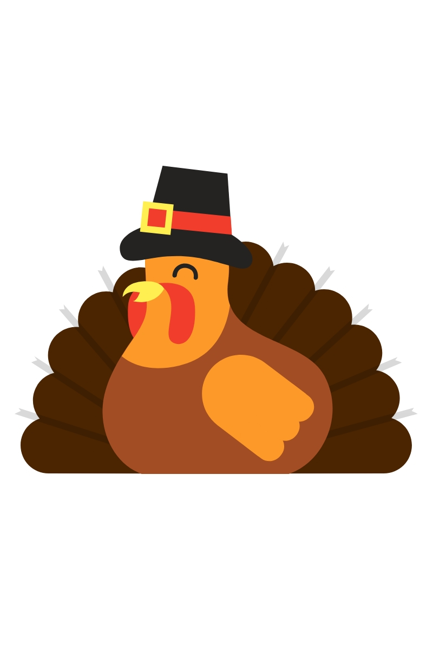

Thanksgiving
Fried Turkey
Chicken & Dressing w/Gravy
Cranberry Sauce
Broccoli Casserole
Corn Casserole
Green Bean Casserole
Macaroni & Cheese
Hawaiian Rolls
Pecan Tart
Pumpkin Pie
Tea & Wine

