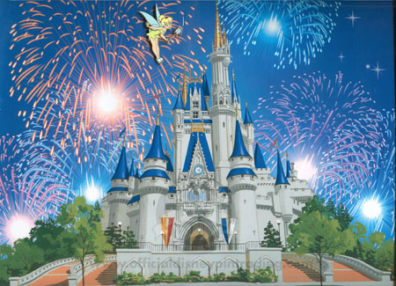
Today is the day!

You’re off to Disney World!

Today’s Highlights:
- 1st Plane ride
- Check-in to the Wilderness Lodge
- Magic Kingdom
  - Big Thunder Mountain
  - Haunted Mansion
  - Electrical Parade
  - Fireworks

