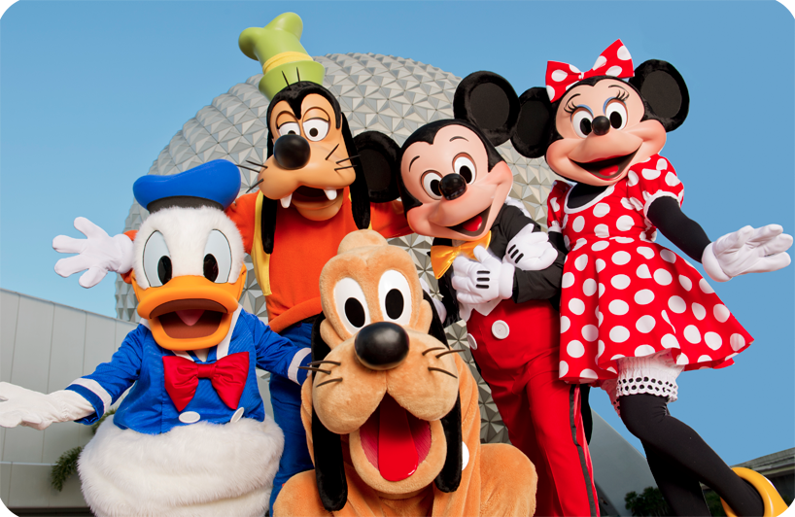
See you at Epcot today!

Today’s Highlights:
- Spaceship Earth
- Mission Space
- Test Track
- Dinner at Le Cellier

Be on the lookout for Crush

